**Assignment -4**

|  |  |
| --- | --- |
| Assignment Date | 22 NOVEMBER 2022 |
| Maximum Marks | 2 Marks |
| Team ID | PNT2022TMID37952 |

**Question:**

Write a code and connections in wokwi for the ultrasonic sensor. Whenever the distance is less than 100cms send an “Alert” to IBM cloud and display in the device recent events.

**Code:**

# #include <WiFi.h>

#include <PubSubClient.h> void callback (char* subscribetopic, byte* payload, unsigned int payloadLength); //-------credentials of IBM Accounts------

#define ORG "kotoq5"//IBM ORGANITION ID

#define DEVICE_TYPE "ESP32"//Device type mentioned in ibm watson IOT Platform

#define DEVICE_ID "12345"//Device ID mentioned in ibm watson IOT Platform

#define TOKEN "12345678" //Token String data3; char server[] = ORG ".messaging.internetofthings.ibmcloud.com";

char publishTopic [] = "iot-2/evt/Data/fmt/json";

char subscribetopic [] = "iot-2/cmd/test/fmt/String";

char authMethod[] = "use-token-auth";

char token[] = TOKEN; char ClientID[] = "d:" ORG ":" DEVICE_TYPE ":" DEVICE_ID;

WiFiClient wifiClient;

PubSubClient client (server, 1883, callback, wifiClient); const int trigPin = 5; const int echoPin = 18; #define SOUND_SPEED 0.034 long duration; float distance; void setup()

{

**Serial**.begin(115200);

pinMode(trigPin, OUTPUT);

pinMode(echoPin, INPUT);

wificonnect();

mqttconnect();

}

void loop()

{

digitalWrite(trigPin, LOW); delayMicroseconds(2); digitalWrite(trigPin, HIGH); delayMicroseconds(10); digitalWrite(trigPin, LOW); duration=pulseIn(echoPin,HIGH);

distance = duration *

SOUND_SPEED/2;

**Serial**.print("Distance (cm): ");

**Serial**.println(distance); if(distance<100)

{

**Serial**.println("ALERT!!"); delay(1000);

PublishData(distance) ; delay(1000); if

(!client.loop()) { mqttconnect();

} } delay(1000); } void PublishData(float dist) { mqttconnect();

String payload = "{\"Distance\":"; payload += dist; payload += ",\"ALERT!!\":""\"Distance less than 100cms\""; payload += "}";

**Serial**.print("Sending payload: "); **Serial**.println(payload);

if (client.publish(publishTopic, (char*) payload.c_str())) {

**Serial**.println("Publish ok");

# }

# else

# {

**Serial**.println("Publish failed");

}

}

void mqttconnect()

{

if (!client.connected())

{

**Serial**.print("Reconnecting client to "); **Serial**.println(server);

while (!!!client.connect(clientId, authMethod, token)) {

**Serial**.print(".")

; delay(500);

} initManagedDevice();

**Serial**.println();

} }

void wificonnect()

{

**Serial**.println();

**Serial**.print("Connecting to ");

WiFi.begin("Wokwi-GUEST", "", 6); while (WiFi.status() != WL_CONNECTED)

{

delay(500);

**Serial**.print(".");

}

**Serial**.println("");

**Serial**.println("WiFiconnected");

**Serial**.println("IP address: ");

**Serial**.println(WiFi.localIP());

}

void initManagedDevice()

{

if

(client.subscribe(subscribetopic))

{

**Serial**.println((subscribetopic)); **Serial**.println("subscribe to cmd OK");

# } else {

**Serial**.println("subscribe to cmd FAILED");

}

}

void callback(char* subscribetopic, byte* payload, unsigned int payloadLength)

{

**Serial**.print("callback invoked for topic:"); **Serial**.println(subscribetopic); for (int i = 0; i < payloadLength; i++)

{ //Serial.print((char)payload[i])

; data3 += (char)payload[i];

}

**Serial**.println("data: "+ data3); data3="";

}

**Diagram json:**

{

"version": 1, "author":

"sweetysharon",

"editor": "wokwi",

"parts": [

{ "type": "wokwi-esp32-devkit-v1", "id": "esp", "top": -4.67, "left": -114.67, "attrs": {}

},

{ "type": "wokwi-hc-sr04", "id": "ultrasonic1", "top": 15.96, "left": 89.17, "attrs": {} }

],

"connections": [

[ "esp:TX0", "$serialMonitor:RX", "", [] ],

[ "esp:RX0", "$serialMonitor:TX", "", [] ],

[

"esp:VIN",

"ultrasonic1:VCC"

, "red",

[ "h-37.16", "v-178.79", "h200", "v173.33", "h100.67" ] ],

[ "esp:GND.1", "ultrasonic1:GND", "black", [ "h39.87", "v44.04", "h170" ] ],

[ "esp:D5", "ultrasonic1:TRIG", "green", [ "h54.54", "v85.07", "h130.67" ] ],

[ "esp:D18", "ultrasonic1:ECHO", "green", [ "h77.87", "v80.01", "h110" ] ]

]

}

**Circuit Diagram:**

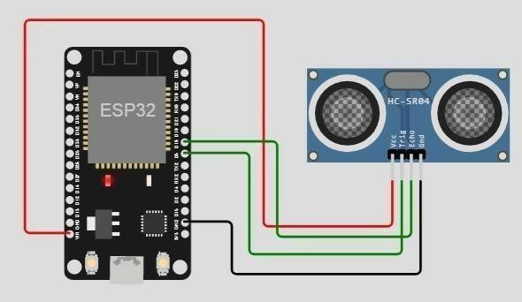

**Output:**

Wokwi output:

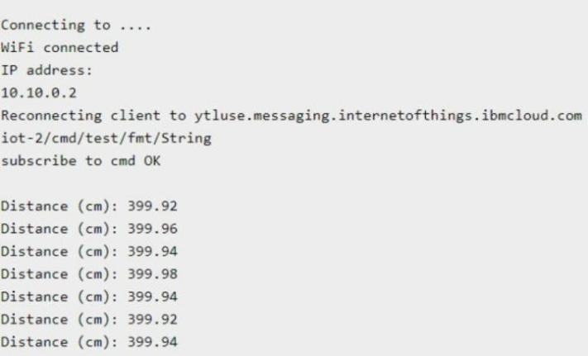

**IBM cloud output:**

